sMS-1000SQ Windows Edition
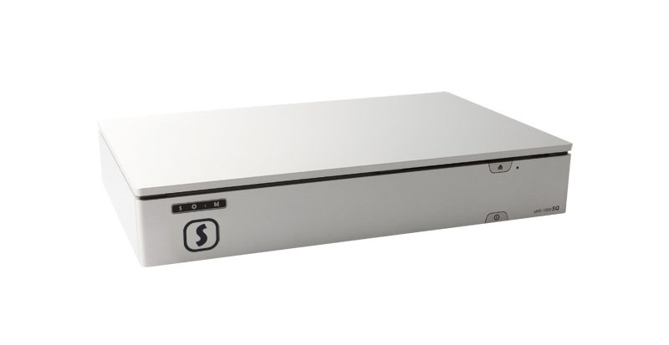

Description
The sMS-1000SQ Windows Edition is the new way of music server based on Windows Server OS besides the original Linux OS based sMS-1000SQ.
Compared to Linux based music servers the diversified compatibility and the program support, the user friendly operation and such convenience functions have been attracted to ensure wide popularity of Windows OS based music servers. We found that Windows Server 2012 R2 based music servers further increased the level of sound quality.
After a longer period of reasearch and testing, SOtM proudly announce the first Windows OS based server which is simply so much better than any existing windows based server on the market, SOtM’s sMS-1000SQ Windows Edition is unequaled and capable to deliver the best sound quality available today.
Here are the key points why sMS-1000SQ Windows Edition is so special,
First, in order to fundamentally enhance the already great sound quality of a Windows Server 2012 R2 based music server, we chose to use the award-winning AudiophileOptimizer from Switzerland based Highend-AudioPC.
The AudiophileOptimizer is gaining popular favor from audiophiles around the world since more than two years. It is installed as first piece of software to ensure the best sound quality possible, even outperforming Linux based music servers. The Audiophile Optimizer specifically optimizes the Windows OS with only one goal in mind, to reproduce the highest sounds quality possible. In short, SOtM sMS-1000SQ Windows Edition is purified Windows OS by Audiophile Optimizer.
Second, the users can easily obtain high quality internet streaming service via ROON, and are capable to build the multi-zone network audio system configuration.
Third, Windows 8.1 OS can be installed as an option for those users desiring the common PC operation such as internet surfing, video playback and etc. With that, the sMS-1000SQ can be referred to Windows OS device, which is specialized in obtaining the high quality sound, allowing using of all functions on Windows OS based on the reputable sMS-1000SQ Hardware performance.
Fourth, sMs-1000SQ Windows Edition uses tX-USBexp as the basic feature and allows external power to the USB audio port presenting the highest sound quality.
Plus, the sMS-1000SQ Windows Edition allows using the internet streaming services like TIDAL or Qobuz, and common music playback programs like Foobar2000 and JRiver.
The sMS-1000SQ Windows Edition offers the best sound & technic as the original sMS-1000SQ does, both sMS-1000SQ series provide the most satisfied sound quality no matter what kinds of audio systems users may desire to build, they can enjoy fantastic sound performance with SOtM sMS-1000SQ server.

Specification
- OS
  - Windows Server 2012 R2 or Windows 8.1
- Available audio playback software
  - Roon
  - TIDAL
  - Qubuz
  - Foobar2000
  - JRiver
  - PowerDVD
  - Etc.
- Basic standard Storage
  - 32G SSD for Windows Server 2012 R2
  - 250G SSD for Windows 8.1 OS
- Optional data storage
  - max.4TB HDD or max.2TB SSD
- USB output model
  - Audio grade USB 3.0 port (tX-USBexp)
  - External power input jack
  - USB power on/off switch
  - USB audio class 2.0 support
  - Support format : 32bit/384KHz PCM, DSD
- Digital output model
  - AES/EBU, Coaxial, Optical output
  - Support format : 24bit/192KHz PCM
- Analog output model
  - Balanced,Unbalanced output
  - Balanced output voltage : 1.9Vrms
  - Unbalanced output voltage : 0.95 Vrms
  - Support format : 32bit/192KHz PCM
  - THD+N : 0.005% > @ 1KHz
  - Output band width : -3dB@100KHz
- Power requirement
  - Input Voltage : +19Vdc
  - Power : Max 60W
- Operating environment
  - Operating temperature : +10 ~ +30℃
  - Storage temperature : 0 ~ +40℃
  - Operating & storage humidity : 10% ~ 90%
- Dimension
  - 360×68×240(mm)
- Weight
  - 4Kg >

FAQ

How to use Tidal or Qobuz with the unit?
If you have both ROON and Tidal accounts, you can enter the id/pw of Tidal account in ROON. To get more information, please check the quick guide If you have Tidal or Qobuz account without ROON’s, connect TIDAL or Qobuz Web player via web browser or run TIDAL or Qobuz application and enter your username and password.

Can I control the unit by Android or iOS devices?
Yes, sure. For iOS, if you choose the sMS-1000SQ Windows Edition with ROON, you can control the unit by ROON apps, please check the minimal requirement on roonlabs.com For Android, if you choose the sMS-1000SQ Windows Edition with ROON, you can control the unit by ROON apps, please check the minimal requirement on https://roonlabs.com

Does it support video playback?
Yes, sMS-1000SQ Windows Edition supports video playback in Windows 8.1 OS. Under 4 Gbyte video file is supportive to playback and DVD & Blu-ray media file may cause problem while playing.

How to play music files from NAS?
It’s very easy and simple, if you use ROON as a software. Please check the quick guide or check https://roonlabs.com

Does the unit necessarily connect to the internet?
Yes, it should be connected to the internet.

Is it available to use with external storage devices?
Yes, it’s possible. Please check the quick guide to get more information.

USB/Digital/Analog outputs
sMS-1000SQ USB output
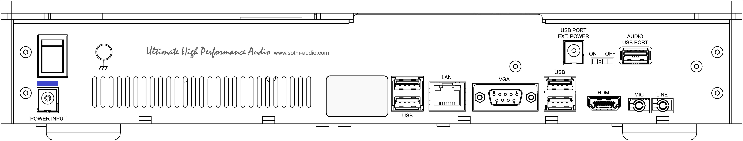
sMS-1000SQ Digital output
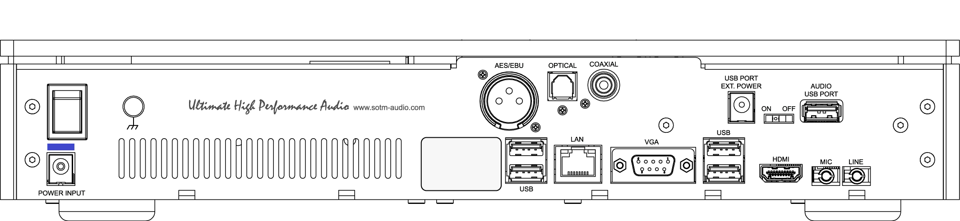
sMS-1000SQ Analog output
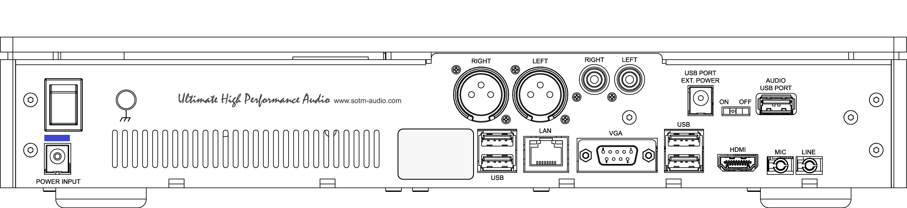

What size of SSD is recommended?
If you own more than 4TB music file, the standard 32GB SSD for OS could be small, so in that case, you can upgrade the standard 32GB SSD to 64GB SSD with extra US$20, you will use the unit in the most cost effective way.

