- This instruction is about how to upgrade the sCLK-EX firmware.
- The example in this instruction uses the sCLK-EX installed into the tX-USBultra.
- Request the firmware before following this instruction, it costs money. To request the firmware, provide us the serial number of your sCLK-EX and which frequencies you want to add or edit.
- Refer to the video for better understanding about the procedure, http://sotmaudio.myds.me:5000/sharing/siRukteb3

How to upgrade the sCLK-EX firmware
1. Download the firmware designed as per your request in your PC.
2. Download and install Atmel Flip software, https://www.microchip.com/en-us/development-tool/flip.
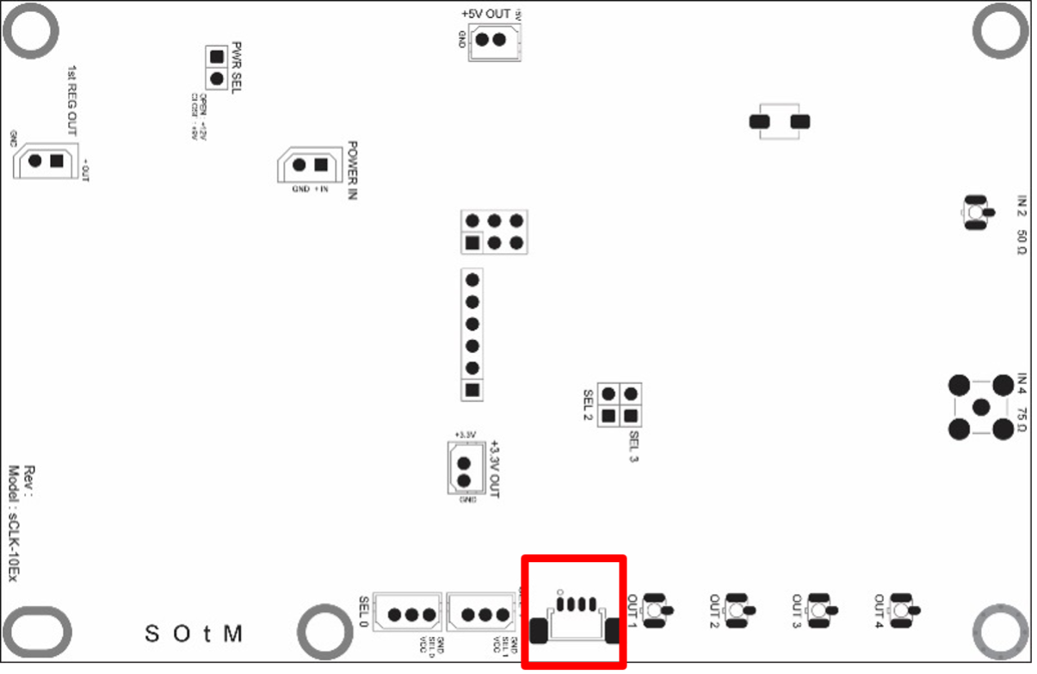
3. Prepare the proper cable to be connected to the red box position on the sCLK-EX.
The following image is the pin map to make the proper cable, and refer to the connector part numbers,
- PCB connector part number : 53398-0471
- Cable connector part number : 51021-0400
- Crimp terminal : 50058-8100
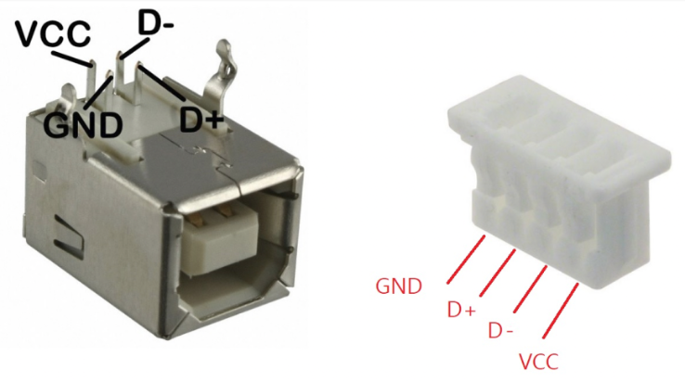
And connect the cable from the PC’s USB port to the red position on the sCLK-EX.
4. Please power on the tX-USBultra. (If you have the sCLK-EX installed in the PC, do not use the PC's power for the firmware upgrade, please use the separate soley power to the sCLK-EX instead.)
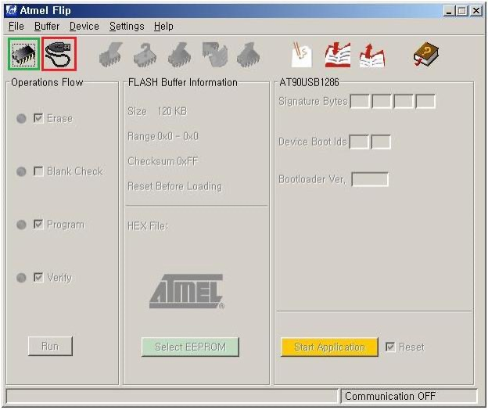
5. Please run Atmel Flip program and click the green marked icon and open the device selection→Atmega8U2→Ok.
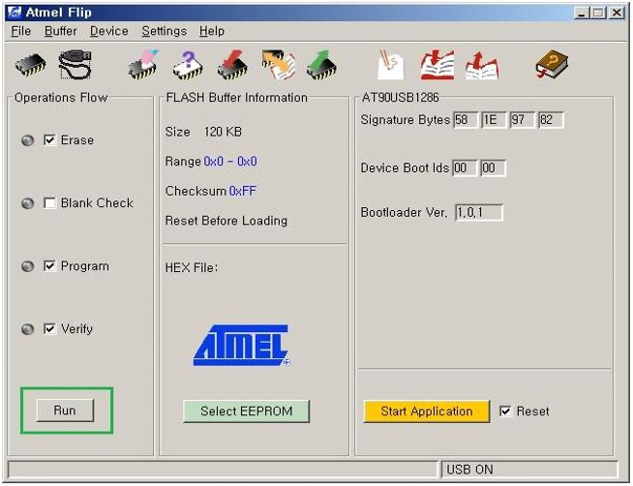
6. And click the red marked icon, select USB→ USB Port Connection→Open.
7. Please click ‘file’ menu and enter ‘Load HEX file’ and select the downloaded F/W file and click ‘OK’ button to load F/W file and Run.
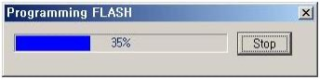
8. The Programming status will be shown as following image.
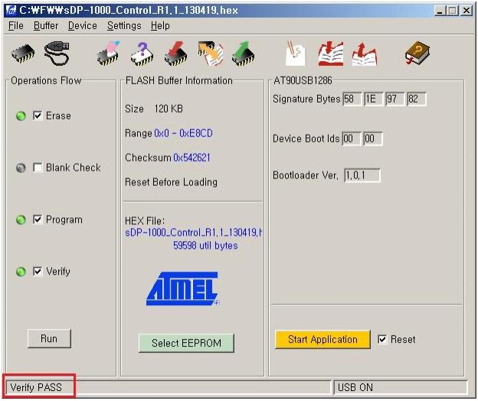
9. Once F/W programming is completed well, ‘Verify Pass’ comment will be shown as the below image.
10. Please exit Flip program and power off and on the tX-USBultra.

