Squeezelite / Logitech Media Server
Squeezelite is a network music player which could be used with Logitech Media Server(aka. LMS). Eunhasu has LMS inside of itself which is available of Tidal, Qobuz and internet radio.
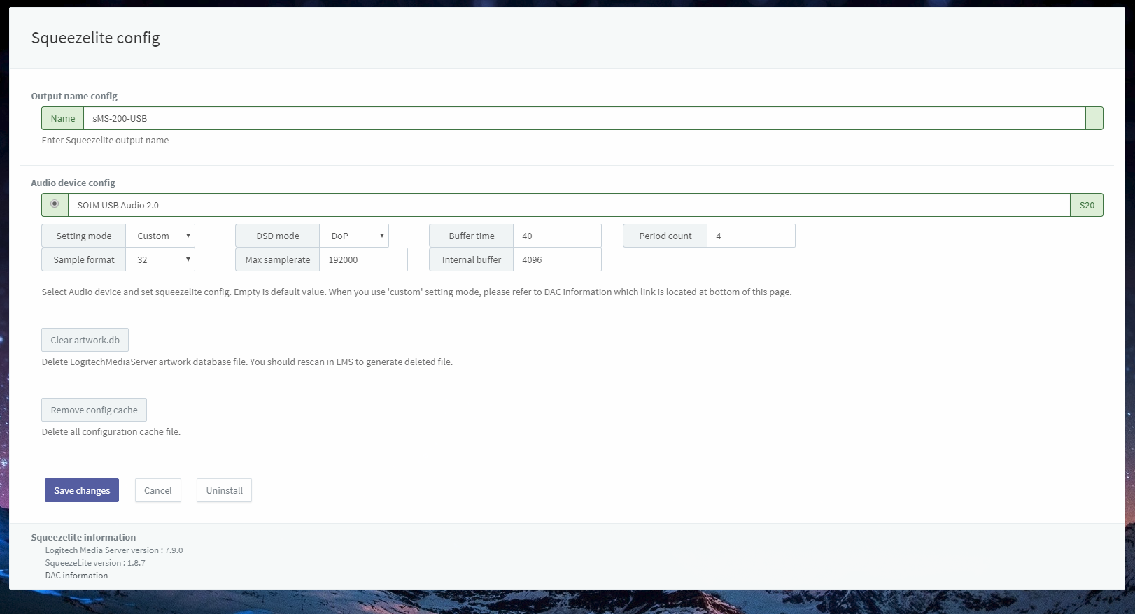full
- Name: A name of Squeezelite device appears on LMS. This could be changed if you would newly name on it.
- Audio device config: Select a radio button of USB DAC which is going to be used and click ‘Save changes’ to use the USB DAC.
  - Setting mode: If you select the 'Default', the audio device is automatically set. If you select 'Custom', you can set up your own audio device.
  - DSD mode: Set the playback method to DoP or Native DSD. If you set to Native, make sure your DAC supports native DSD playback.
  - Buffer time: Set the buffer length of music file data to be transmitted to the audio device in microseconds.
  - Period count: Set the transmission period of the music file data of the audio device.
  - Sample format: Set the music file transmission format (sample format) supported by the connected audio device. (Hovering the mouse cursor over the text box will display the maximum sample format of the connected Audio device.)
  - Max sample rate: Set the sample rate for the connected audio device which it can be supportive. (Hovering the mouse cursor over the text box displays the maximum sample rate.)
  - Internal buffer: Specifiy the maximum buffer size in kilobytes for audio processing.
- Clear artwork.db: Use when icons in LMS shatter. You should rescan in LMS after that.
- Remove config cache: Delete the LMS configuration cache files.

Configuration
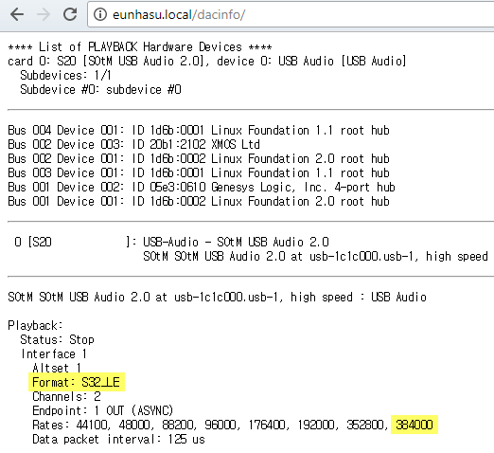
Check your DAC's capability.
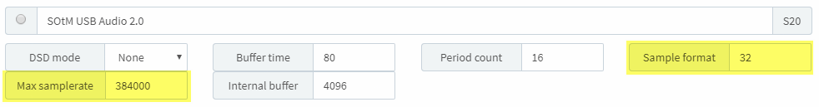
Input 'Max samplerate' and 'Sample format' by DAC information. Please refer to highlighted part.

LMS library rescan guide
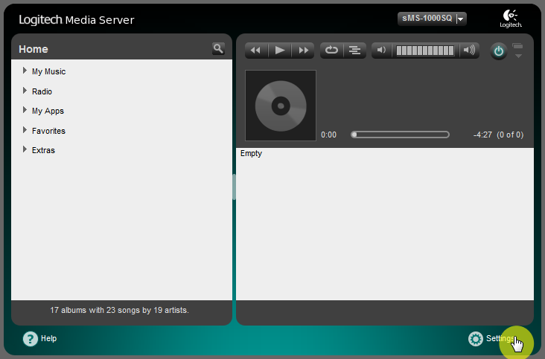
Move on to Settings menu page.
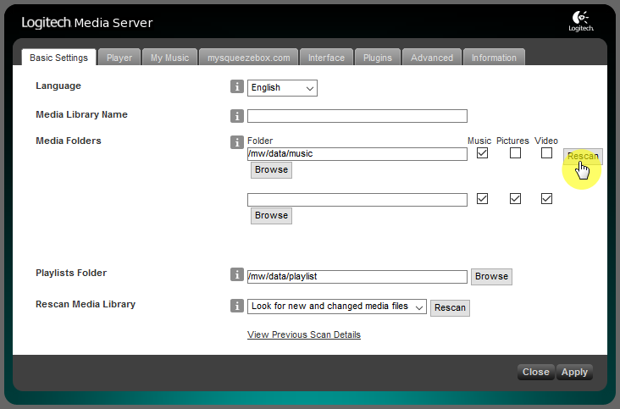
Click “Rescan” button to start scan on Basic Settings tab.
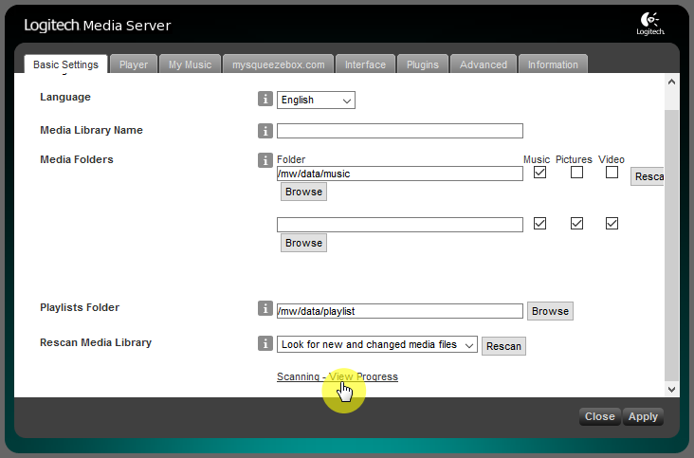
Click “Scanning - View Progress” link at bottom of page if you'd like to see scanning states.
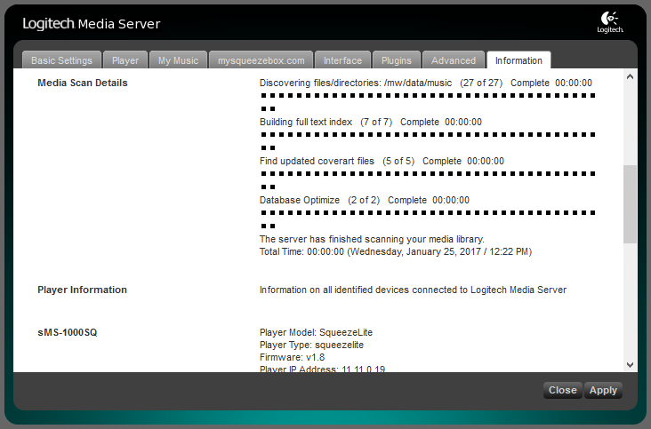
Scanning states screen.

How to use Tidal in LMS
http://docs.sotm-audio.com/doku.php?id=how_to_use_tidal_in_lms

Video: how to install and set Spotify plugin in LMS; Spotify premium account required.

