sMS-200
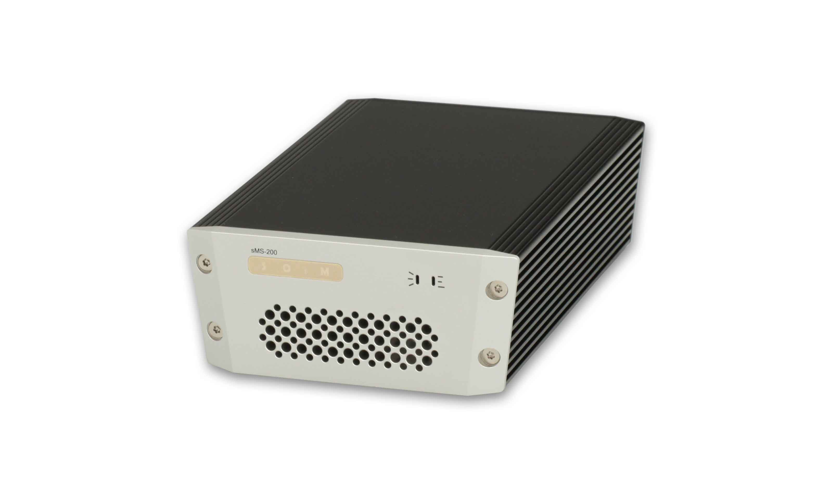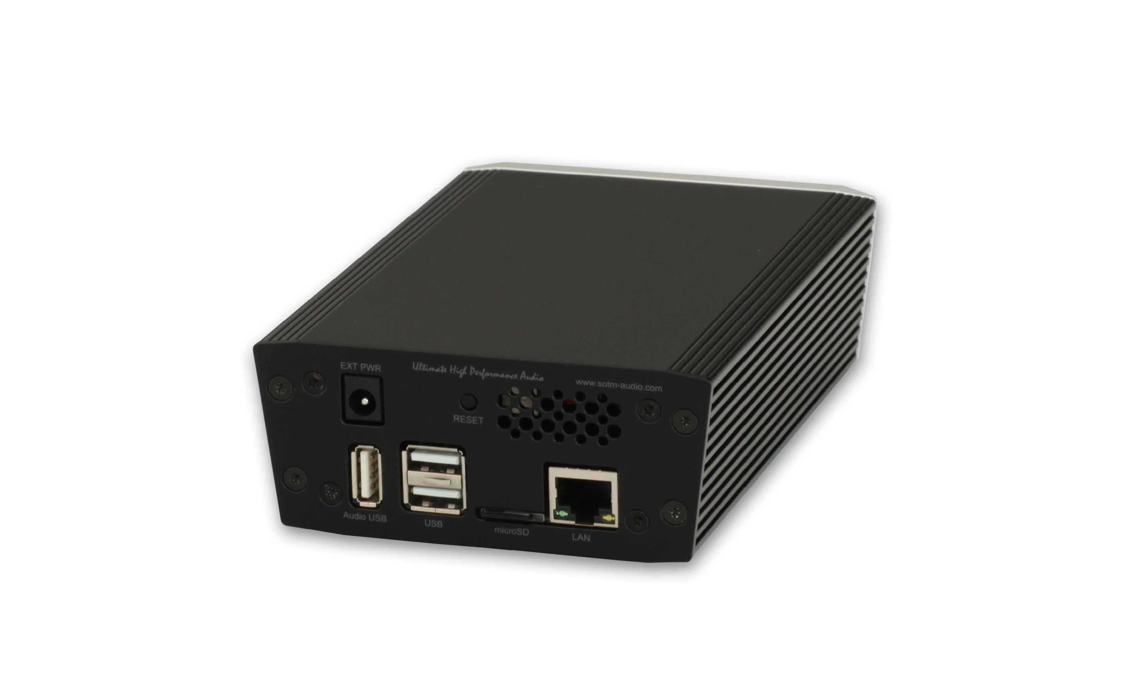
sMS-200 is a new generation of mini network player.
- Description
- sMS-200 User Guide

