sMS-1000SQ
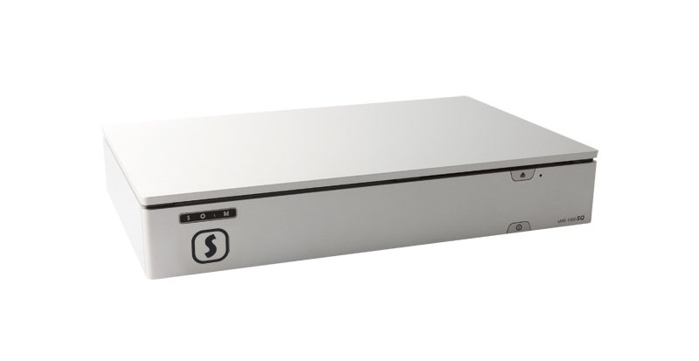
sMS-1000SQ is a music file player and server, it browses, shares and plays music files in the network or stored in the product.
- Windows Edition description
- Eunhasu Edition description
- Eunhasu usage

Exterior

Front Panel
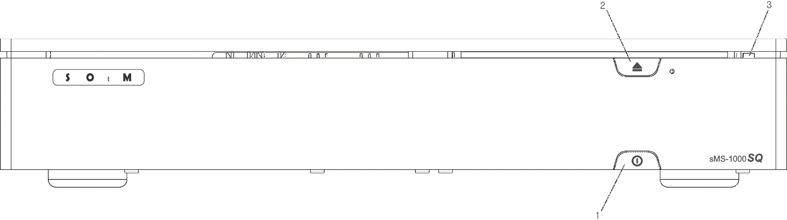
- Standby button: Power ON/OFF the unit.
- Eject button: Eject an optical disk. (Use when an optional optical drive installed)
- Indicator lamp: Indicate the power status. If the storage devices is operating, the lamp is blinking.

Rear Panel - sMS-1000SQu
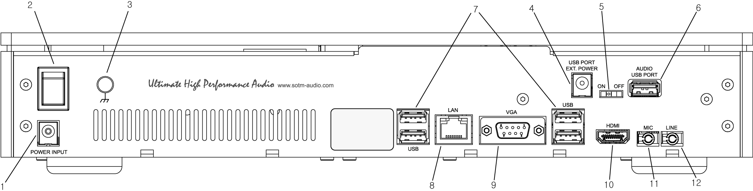
- Power input jack: Connect to a power supply.
- Power input switch: Turn ON/OFF power of the unit.
- Earth terminal: Connect to earth(ground).
- External power input jack for AUDIO USB PORT: If you want to use external power to AUDIO USB PORT, you can use 6.5Vdc ~ 9Vdc, 2A power.
- Power switch for AUDIO USB PORT: Turn ON/OFF +5.0v power of AUDIO USB PORT. If the connected USB audio device use USB port power, switch to ON.
- AUDIO USB PORT: Connect to USB audio device.
- USB port: Connect to non-USB audio device if needed.
- LAN port: Connect to a router by network cable.
- VGA port: Connect to a monitor by VGA cable if VGA display is needed.
- HDMI port: Connect to a monitor by HDMI cable if HDMI display is needed.
- Line-out jack: Main board analog audio output jack.
- Mic-in jack: Main board microphone input jack.

Rear Panel - sMS-1000SQd
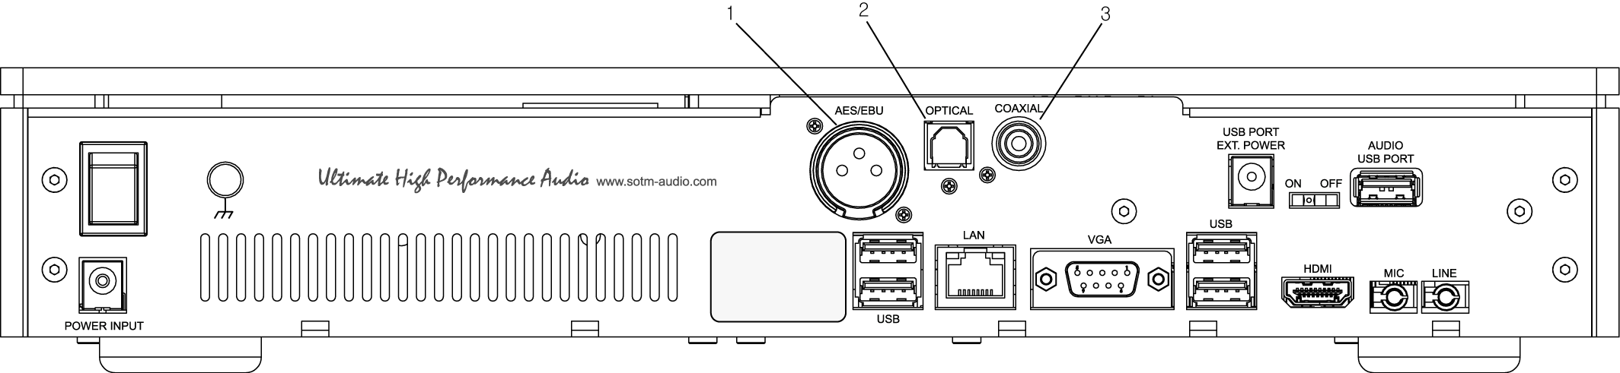
- AES/EBU digital output: Connect to AES/EBU input of DAC.
- Optical digital output: Connect to optical input of DAC.
- Coaxial digital output: Connect to coaxial input of DAC.

Rear Panel - sMS-1000SQa
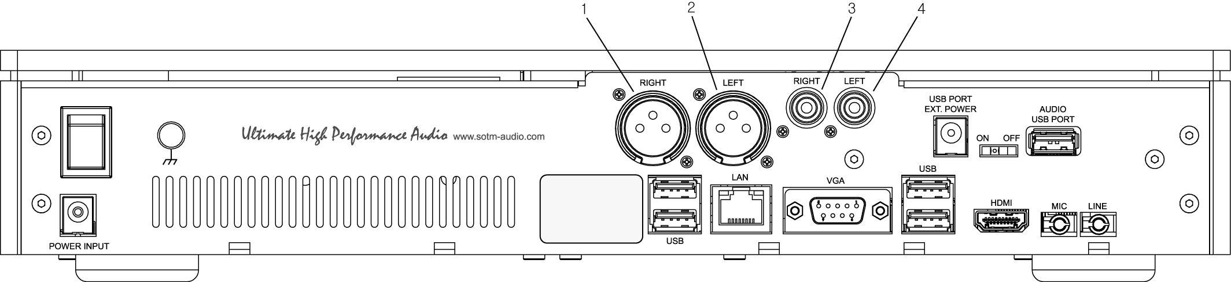
- Right balanced analog audio output: Connect to right balanced analog audio input of amplifier.
- Left balanced analog audio output: Connect to left balanced analog audio input of amplifier.
- Right unbalanced analog audio output: Connect to right unbalanced analog audio input of amplifier.
- Left unbalanced analog audio output: Connect to left balanced analog audio input of amplifier.

