Shairport
Shairport is a clone of Apple®'s AirPlay® feature. You can playback music when you used AirPlay® of Apple® product.

Shairport config page is simple and just select output audio. 'Name' item is for Apple® iDevices.

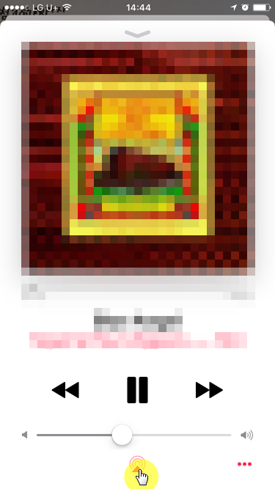
Example operation by Music app. Other apps could be different UI/UX to select audio output. Touch airplay icon at bottom of Music app,
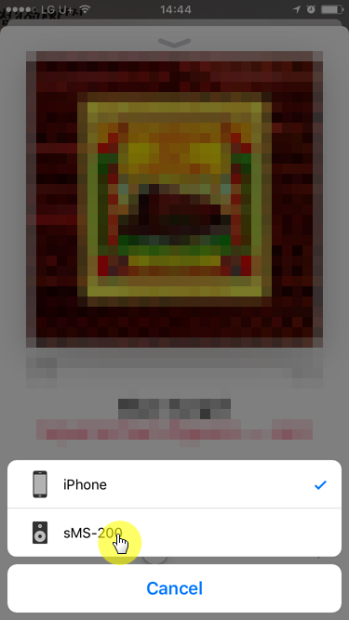
You can select output device like screen shot. Like example capture screen, if you select sMS-200, music would be out from sMS-200 device.
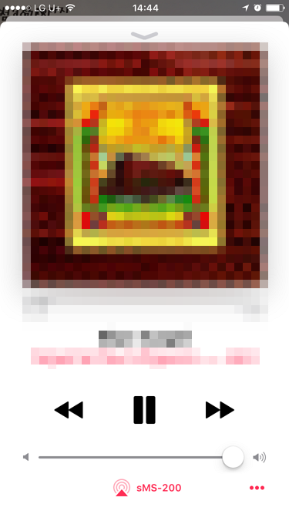
finish setting.

Last Updated:

