MinimServer
MinimServer is one of the best UPnP Audio Server. MinimServer collects user's music intelligently and operates by DLNA control point such as Bubble UPNP. You can search and playback your music files more convenient.
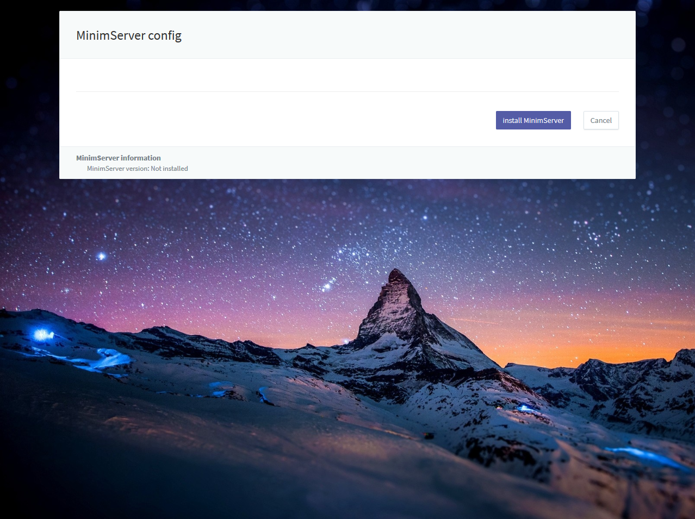
MinimServer should be installed by an user. Installation is available in MinimServer config page.
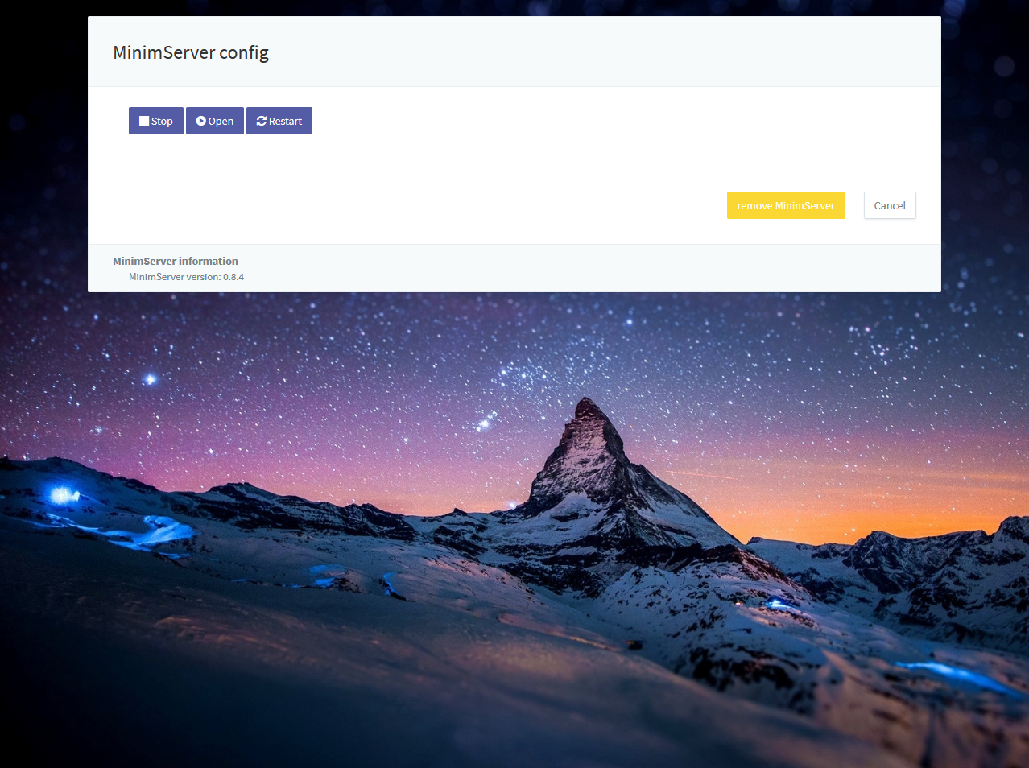
MinimServer can be controlled in MinimServer config such as start, open, stop or restart after installation done.
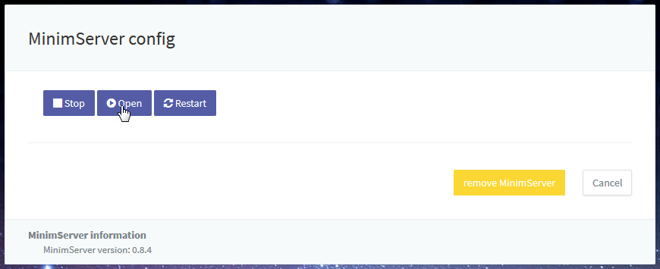
Content directory of MinimServer setting has to be set in MinimServer config page which could be open after starting MinimServer.
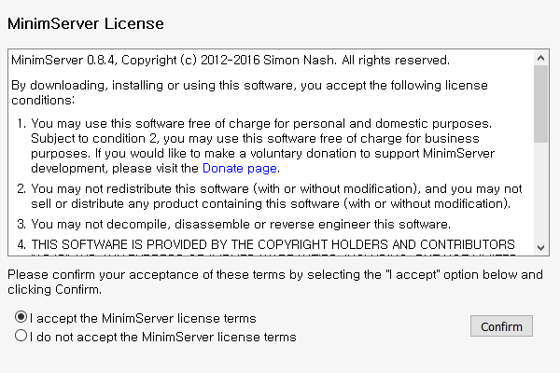
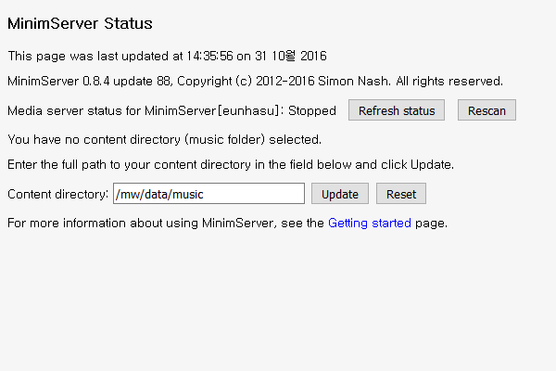
First to use, you have to accept MinimServer license terms. Set contents directory and press 'Update' button.
- Content directory shoule be /mw/data/music to collect musics in Eunhasu system.
- If /mw/data/music space are 100% full, the main system would be in abnormal status and not be operating normally.

Last Updated:

