LibreSpot
LibreSpot is a open source implementation for Spotify-connect® which is served from Spotify®.
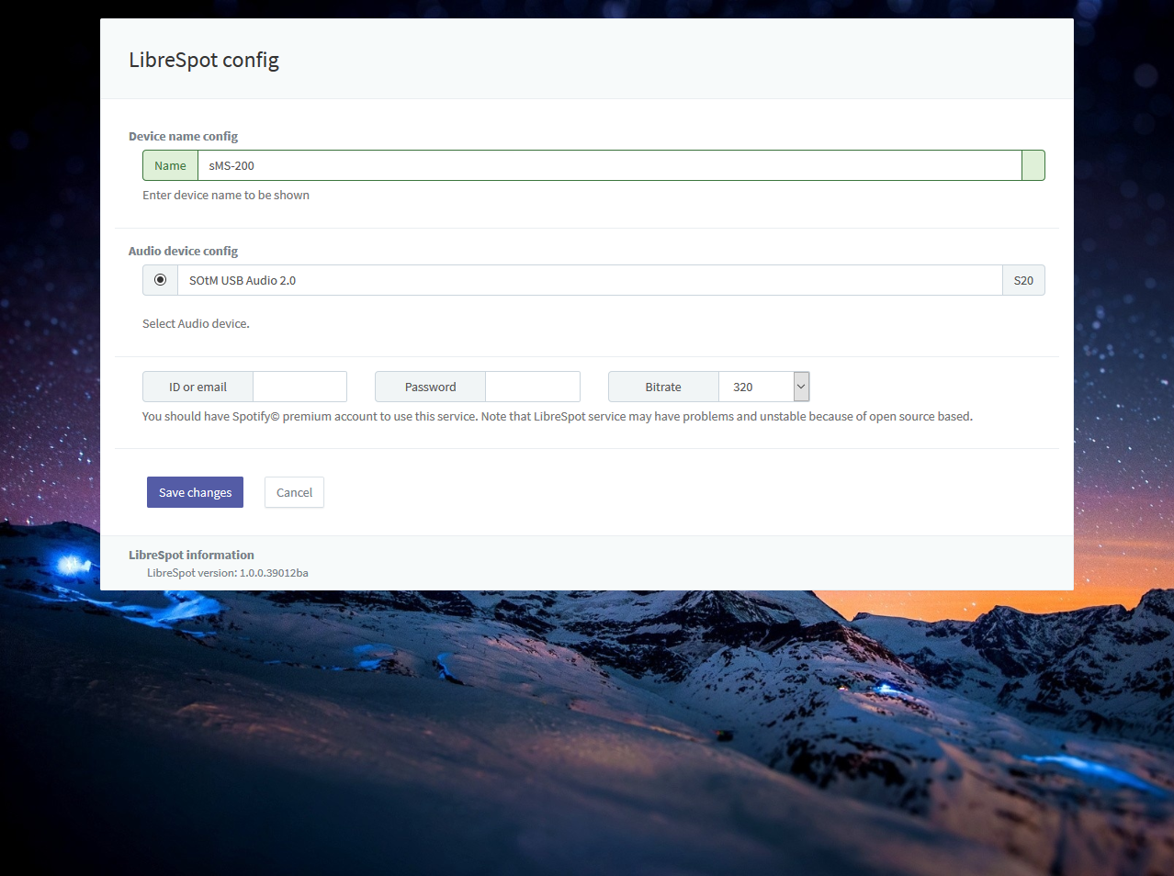
LibreSpot requires Spotify© premium account to use service. Note that LibreSpot service may have problems and unstable because of open source based service.

