HQPlayer NAA
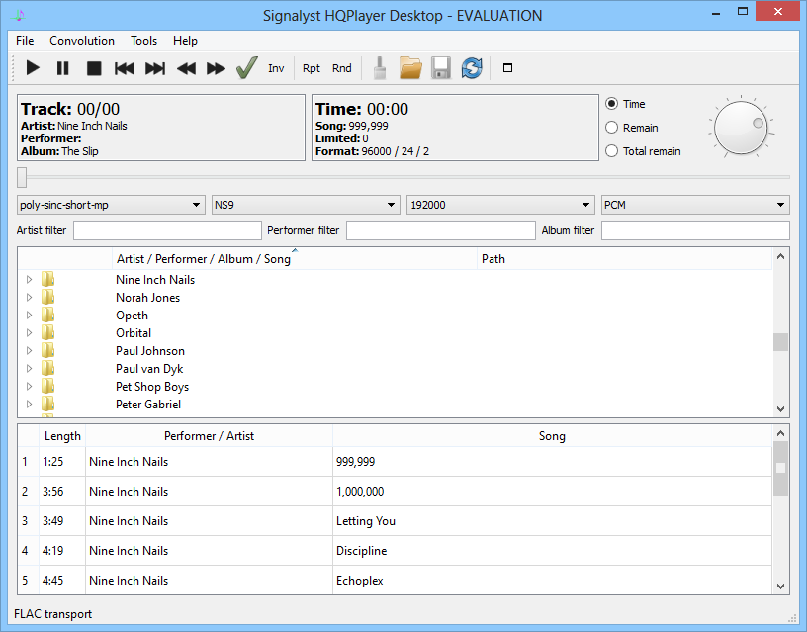
HQPlayer Desktop is a high performance media player to be able to upsample music file on Windows, mac and Linux OS. HQPlayer NAA is working like a bridge to connect HQplayer Desktop over network to plays music files bridge between HQPlayer Desktop and device via local network. Especially, NAA is a superb for DSD playback.
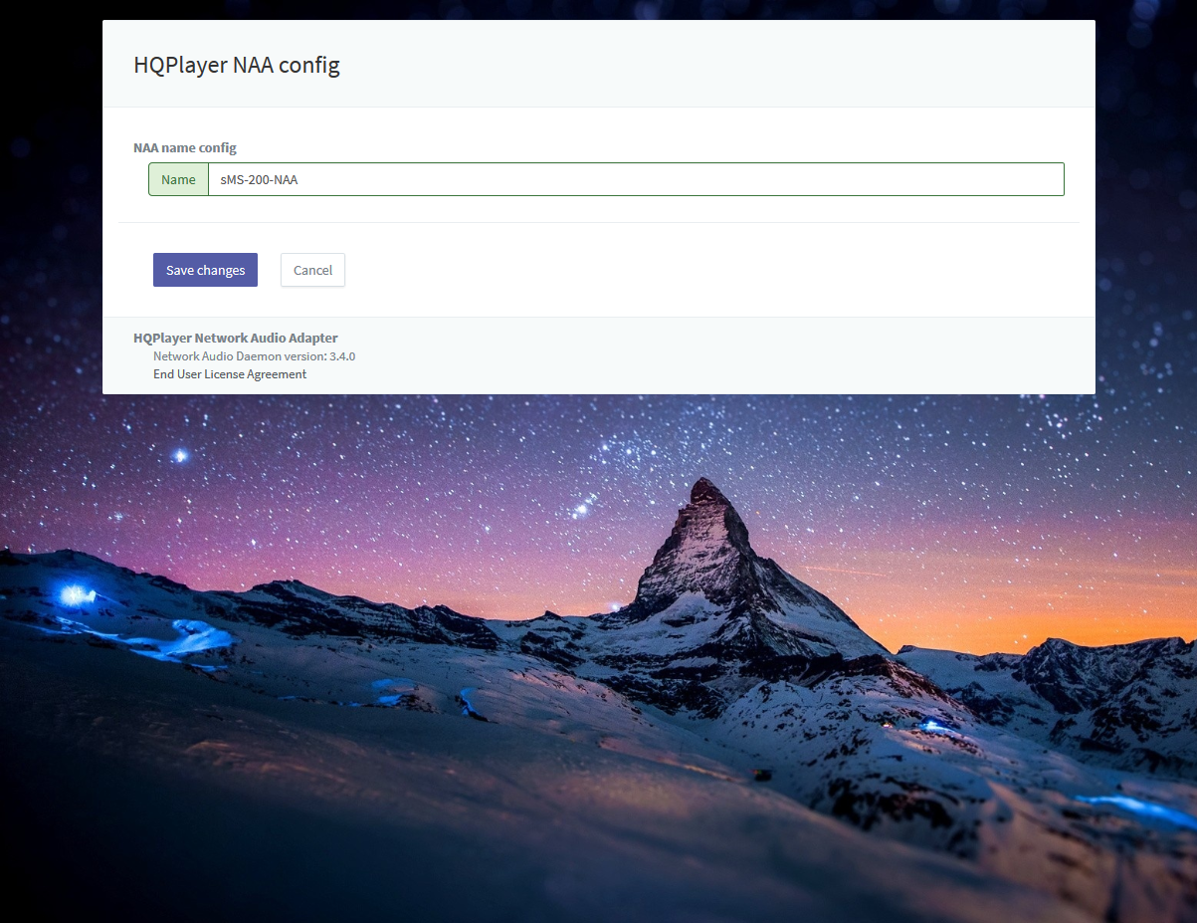
You can change the device name.
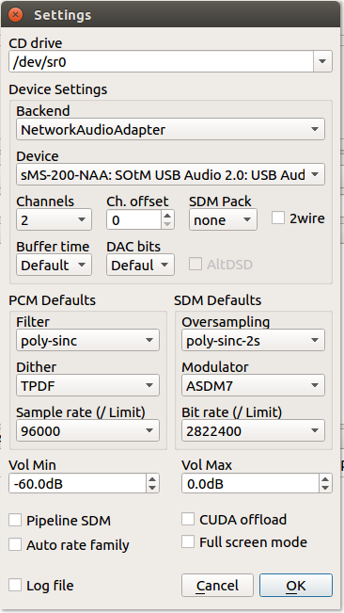
This screen shot is from HQPlayer Desktop settings menu.

simple demo video

Last Updated:

